# NATIONAL ASSOCIATION OF UNIVERSITY WOMEN

Volume 4, Issue 6

March 2014

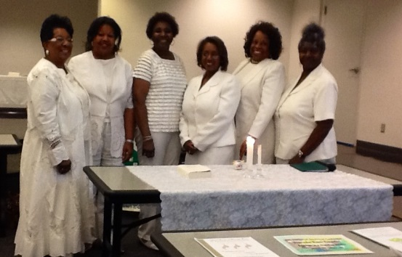

**My NAUW Culver City Sisters,**

My thanks to everyone who helped to make our **Black History Month** meeting a memorable one. Our special thanks to members who made special presentations: **First Vice President Mildred Slaughter; Corresponding Secretary Herracia Brewer; and Southwest Sectional Director Evelyn Wright.** And thanks to **John Ricks** for allowing us to borrow some of his African art for display at our meeting. We had a great potluck that everyone seemed to enjoy with more than enough food for all. Each member was resplendent in their African attire in honor of **Black History Month.**

Now the time has come for us to focus and devote our time and energy to our community service project – the **Community Fair** scheduled for **Saturday, April 26, 2014,** to be held at **St. John’s United Methodist Church from 10:00-3:00 p.m.** We need to pre-register 25 women in order for the mobile unit to come out. All members are asked to find some women who need to have a mammogram exam. The requirements are as follows: The woman must be over 40 years of age. She does not have health insurance. She has not had a mammogram in a year.

The photo above is of our newest **Culver City** member at her induction ceremony in January. **Roberta Jones, Welcome!!**

Just a reminder to all members that we will be attired inwhite for the **Founders’ Day Ceremony on Sunday, which will be held at approximately 3:30 p.m.** All members present will participate in the ceremony to honor the **Founders of the** **National Association of University Women (Mrs. Mary Church Terrell, Dr. Sara Brown, Dr. Fairfax Brown, and Miss Mary Cromwell)** and the **Forever Emeralds** who helped to carry on the legacy of the **Founders.**

It is important that we are punctual in starting our regular meeting so that we can perform the Ceremony in a timely manner, and we may have some guests from another branch to come and join us in our tribute to the **Founders.**

**SAVE THE DATE OF April 26, 2014, for the** **COMMUNITY FAIR.**

**God bless you!**

**Helen Ricks, President**

.

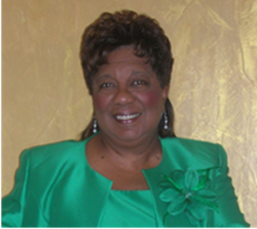

CULVER CITY STAR

## **PRESIDENT’S CORNER**

culver city nauw:

**Executive Board 2012-2014**

**President**

**Helen Ricks**

**1st Vice President**

**Mildred Slaughter**

**2nd Vice President**

**Carolyn Williams**

**Recording Secretary**

**Clarissa Andrews**

**Corresponding Secretary**

**Herracia Brewer**

**Financial Secretary**

**Hester Watkins**

**Treasurer**

**Kenya Dennis**

**Historian**

**Dr. Virginia Hathaway**

**Parliamentarian**

**Dr. Claretha Graham**

**Immediate Past President**

**Mildred Slaughter**

**SECTIONAL DIRECTOR**

**EVELYN L. WRIGHT**

**NATIONAL PRESIDENT**

**DOLORES Y. OWENS**

**NATIONAL THEME:**

**“Women Moving Forward with Purpose and Pride”**

**CULVER CITY STAR**

Page 2

Paul wrote,“I have learned to be content whatever the circumstances. ”

Philippians 4:11

BIRTHDAYS AND ANNIVERSARIES

**March**

**Kathleen Phillips 3/31**

[Type a quote from the document or the summary of an interesting point. You can position the text box anywhere in the document. Use the Drawing Tools tab to change the formatting of the pull quote text box.]



SICK AND SHUT-IN

### **Dates to Remember**

**Community Fair Saturday, April 26, 2014 St. John’s UM Church 1715 Santa Ana Blvd.**

**Spotlight on Youth Luncheon, Sunday, April 27, 2014, 1:00 p. m. Doubletree by Hilton Torrance $65**

**Mailing Address**: NAUW Culver City Branch P.O. Box 2524 Culver City CA 90231-2524



Continue to pray for the following members: Evelyn Wright and family; Odessia Love, who is recuperating; Carolyn Williams, who is mending from a broken foot. Keep Dr. Virginia Hathaway and her family in prayer. Her mother was recently hospitalized.

